Lasagna Recipe (Ray)
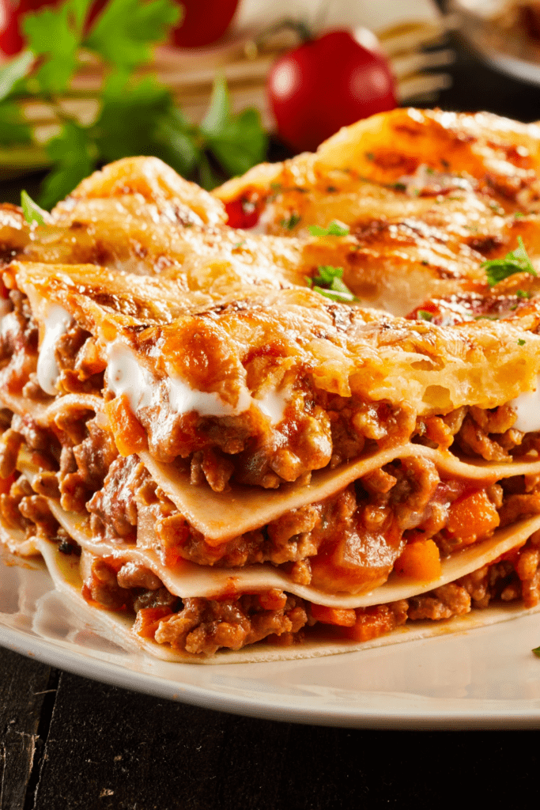
INGREDIENTS
- 1/2 box Barilla Wavy Lasagne
- 1 pound bulk Italian sausage or ground beef (cooked and drained)
- 2 jars Barilla Marinara Sauce
- 1 15-oz container ricotta cheese
- 4 cups shredded mozzarella cheese
- 1/2 cup Parmigiano-Reggiano, grated
- 2 eggs, lightly beaten

iNSTRUCTIONS
- Preheat the oven to 375 degrees Fahrenheit.
- Cook the noodles in boiling water for 4 minutes and drain with a colander. Run it through cold water to stop from further cooking. Set aside.
- In a large saucepan, mix sausage or ground beef and 1 1/12 of the marinara sauce. Let it simmer for 5 minutes.
- In a separate bowl, mix Ricotta, 3 1/2 cups of mozzarella, Parmigiano-Reggiano, and eggs.
- Grease a lasagna pan or a 9×13-inch baking dish with cooking spray.
- Spread a thin layer of the marinara sauce over the baking dish, about 3/4 cup. Layer 3 to 5 lasagna noodles over the sauce. The noodles should only overlap slightly with each other. Layer the cheese mixture of the noodles, followed by the meat sauce.
- Repeat the layers starting from the noodles to the meat sauce twice. Top the meat sauce with the remaining marinara sauce and sprinkle with the remaining mozzarella cheese.
- Cover the baking dish with foil and bake for 30 minutes. Remove the foil and cook for an additional 10 minutes.
- Let the lasagna sit for 10 minutes before slicing and serving.
Bon Appetit

